

**本科实验报告**

|  |  |
| --- | --- |
| 课程名称： | 计算机体系结构 |
| 姓 名： | 周炜 |
| 学 院： | 计算机科学与技术学院 |
| 系： | 计算机科学与技术系 |
| 专 业： | 计算机科学与技术 |
| 学 号： | 3210103790 |
| 指导教师： | 卜凯 |

2023年 11 月 11 日

Lab 3&4: Cache Design & Pipelined CPU with Cache

周炜 3210103790

1. **Purpose**

Understand Cache Line.

Understand the principle of Cache Management Unit (CMU) and State Machine of CMU.

Master the design methods of Cache Line，CMU and Integrate it to the CPU.

Master verification methods of Cache Line, CMU and compare the performance of CPU when it has cache or not.

1. **Task**

Design of Cache Line and CMU.

Verify the Cache Line and CMU.

Observe the Waveform of Simulation.

Design of Cache Management Unit and integrate it to CPU.

Observe and Analyze the Waveform of Simulation.

Compare the performance of CPU when it has cache or not.

1. **Experimental process**
   1. **Experimental principle**

The cache controller is a hardware block responsible for managing the cache memory, in a way that is largely invisible to the program. It automatically writes code or data from main memory into the cache. It takes read and write memory requests from the core and performs the necessary actions to the cache memory or the external memory.

In **Experiment 3** we will implement this cache, and in **Experiment 4** we will implement the cache controller (a finite state machine), and then connect the cache to the cpu

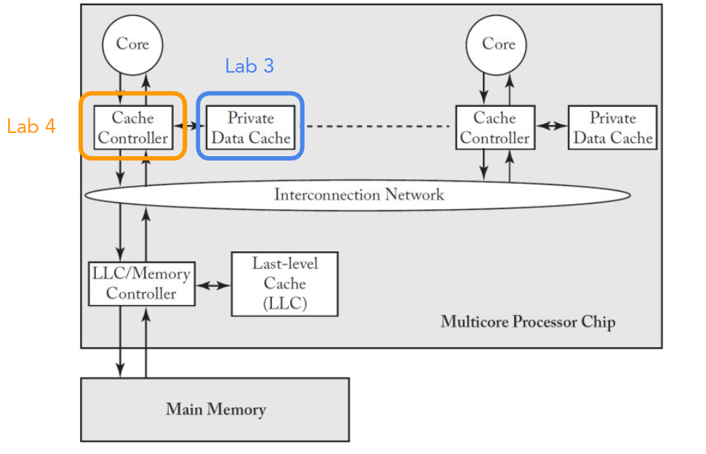

**Cache Overview**

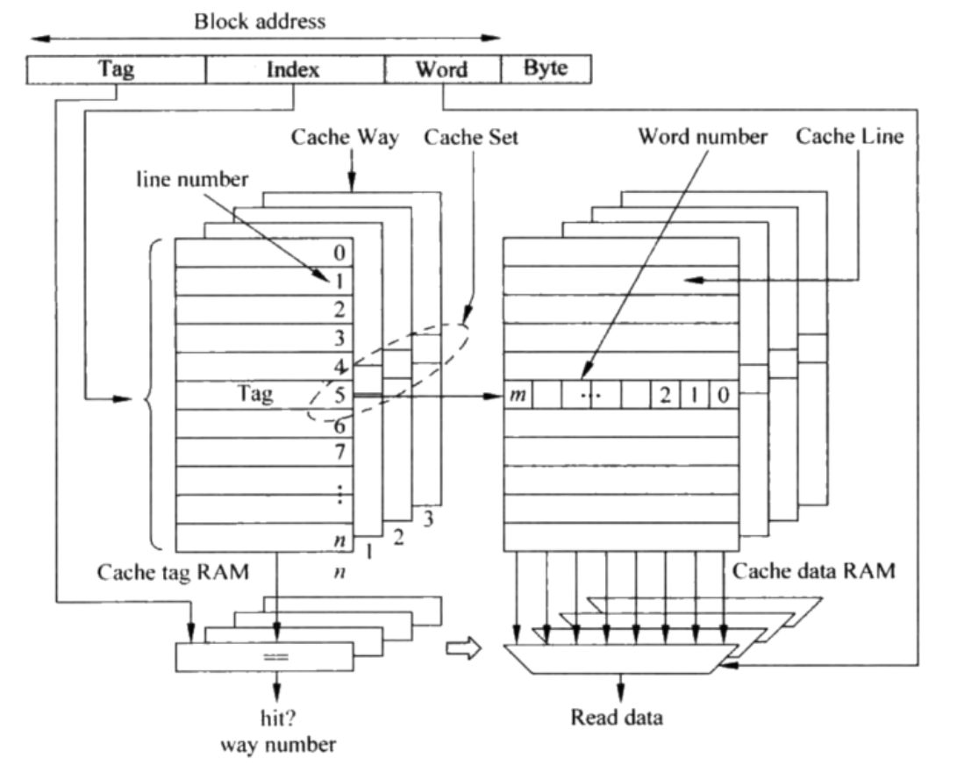

**Byte offset**: Indicates which byte within this word.

**Word offset**: Indicates which word within this cache block.

**Index**: Corresponds to the line number.

**Tag**: Determines hit/miss; if it's a hit, it indicates which cache way was hit.

First, you use the index to access a specific line, which corresponds to **4 cache ways.**

Then, you compare the tag to decide if it's a hit and, if so, which cache way was hit. After that, you use the word offset to determine which word the multi-way selector chooses from the data.

**Cache configuration**

|  |
| --- |
| 64 cache lines Cache Line Size = **16 Byte**s = 4 words = 4 * 32 bits  **2-way set** associative  Replacement policy: LRU  Write policy: Write Back, Write Allocate |

**Write policy details**

**Hit**:

In a write-back scenario, the data is only written to the cache and is later written back to memory when the block needs to be replaced. An additional dirty bit is used to track whether the cache block has been modified. (Fast but less reliable, may lead to inconsistency issues) If dirty = 1, then a write-back is needed.

**Miss**:

In a write allocate situation, similar to a read miss, the block is first brought into the cache before writing data to it.

**Address Decoding**

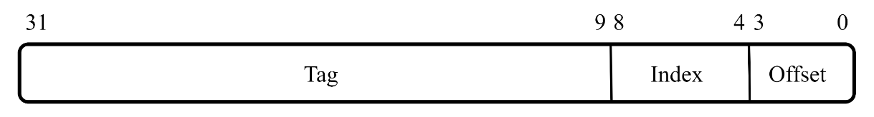

**Cache block configuration**

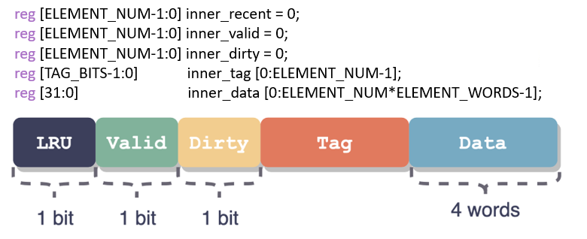

1. The offset includes both byte offset and word offset, as the cache line size is 16 bytes (4 words), with each word being 4 bytes, resulting in a 4-bit offset.
2. The index field consists of 5 bits, as there are 64 cache lines with a two-way set-associative configuration, subtracting one bit for the index.
3. The remaining bits are reserved for storing the tag, making the tag field 23 bits.
   1. **Cache Design and Access**

Mainly refer to the following flow chart to fill in the code

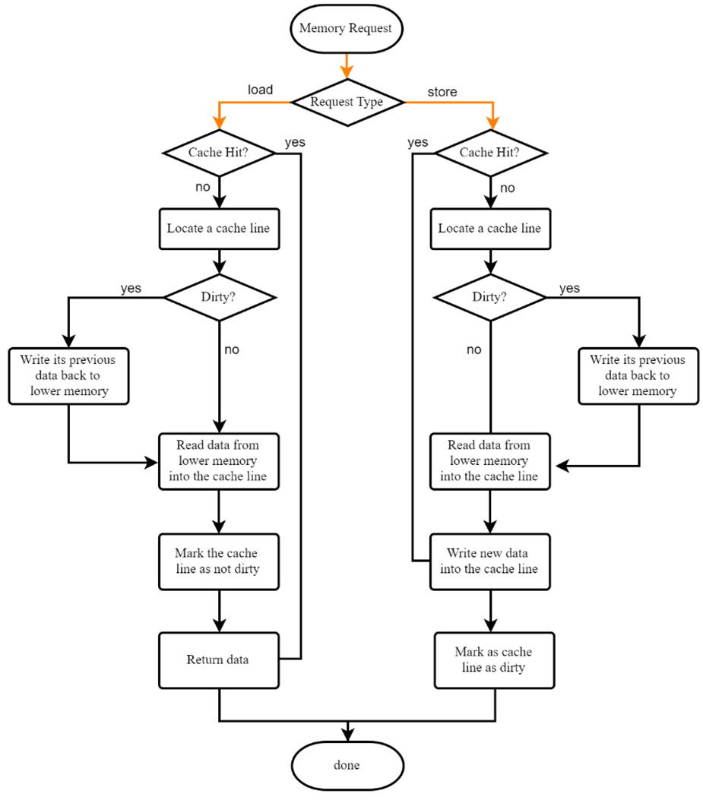

Fill in **cache.v** symmetrically ( way 2 just follow way 1's step)

**u_b_h_w** corresponds to the judgment of lb, lbu, lh, lhu instructions, the **highest bit** represents unsign or sign, the last two bits represent **10** for word, **01** for half word, and **00** for byte.

Note that the **edit** here corresponds to the core issuing a store instruction, and the **store** is actually written after the pipeline has passed(if miss, will do it in **S_FIFL**).

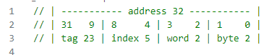

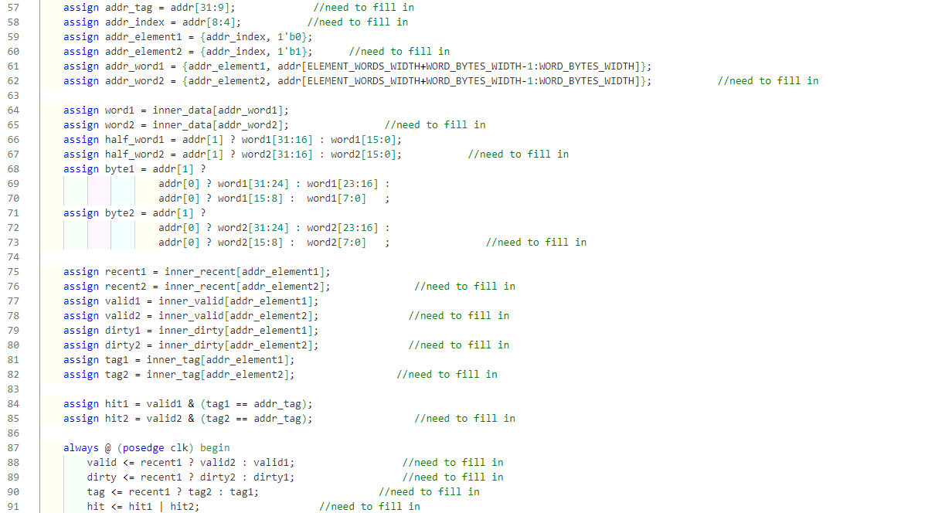For hit1, which is the first hit, so the first hit is the most recently accessed, and the recent position is 1 (LRU replacement strategy)

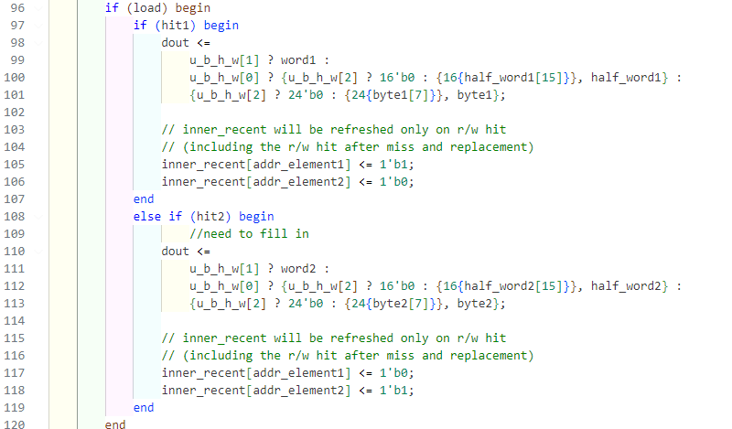

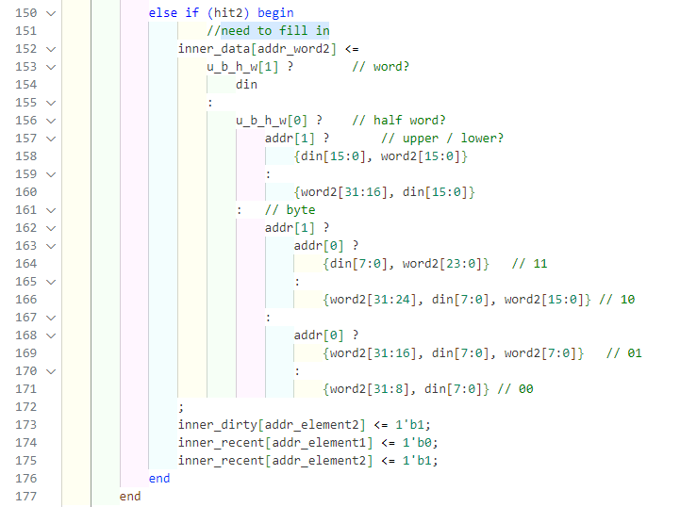

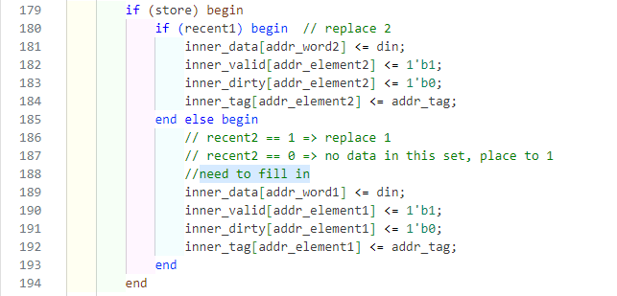

where the code inside the box is the equivalent writing of the code outside the box

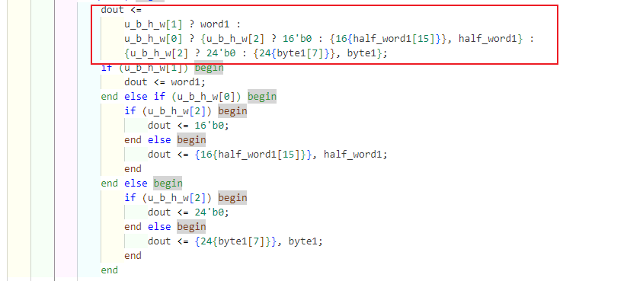

* 1. **Cache Controller**

**3.3.1 The Overall View**

The cache controller is used to connect and communicate with the CPU and memory. Our cache will also be defined under this module. First, let’s take a look at the interface between the cache controller and the CPU and its interface with memory.

F irst, the CPU side needs to receive read and write requests, and after processing the requests, the data needs to be returned. In this process, it needs to know whether it is reading or writing, the type of reading and writing, the reading and writing addresses, and what data is written if it is written. After processing the request, if you want to read the data, you need to return the data to the cpu.

Then on the memory side, the dirty data needs to be written back to memory, or the data needs to be loaded from memory. In the experiment, when the cache and memory interact with each other, data is sent word by word. Every time a word is read and written successfully, the memory will give an **ack signal**.

In fact, cache controller is used to control the **load**, **edit** or **store** operations of cache. How to arrange these operations will be explained later.

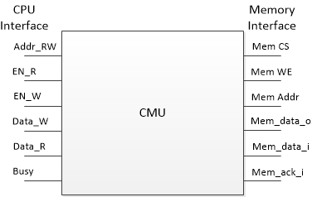

All cache operations occur on the **falling edge** of the current state, and memory operations occur on the **rising edge** of the current state.

First of all in the cpu side need to receive read and write requests, after processing the request need to return data. In this process, it needs to know whether to read or write, the type of read and write, read and write addresses, and what data to write if writing. After the request is processed, the data should be returned to the cpu if it is read.

Then on the memory side, it needs to write the dirty data back to memory, or load data from memory. Inside the experiment, when the cache and memory interact with each other, the data is sent one word at a time, and every time a word is successfully read or written, memory will give an ack signal.

The interface is (yellow is CPU side, blue is MEM side):

cmu CMU (.clk(debug_clk),.rst(rst),.addr_rw(ALUout_MEM),

.en_r(DatatoReg_MEM),.en_w(mem_w_MEM),.u_b_h_w(u_b_h_w_MEM),

.data_w(Dataout_MEM),.data_r(Datain_MEM),.stall(cmu_stall),

.mem_cs_o(ram_cs),.mem_we_o(ram_we),.mem_addr_o(ram_addr),

.mem_data_i(ram_dout),.mem_data_o(ram_din),.mem_ack_i(ram_ack),

.cmu_state(cmu_state));

**3.3.2 state machine**

The implementation method is a state machine. Cache operations all occur on the falling edge of the current state, and memory operations all occur on the rising edge of the current state. There are mainly 5 states.

**S_IDLE**: Idle state, no memory operation is performed, and it is always in this state when the cache operation hits.

**S_PRE_BACK**: In order to write back, first read the cache data that needs to be written back.

**S_BACK**: The rising edge writes the data of the previous state back to the memory. The falling edge reads the data that needs to be written back from the cache next time (so the last read is meaningless). It is controlled by the counter until the entire cache line is written back. Each time a word is written back, a total of 4 words in a cache line need to be written back **4 times**. During this period, it is necessary to wait for the memory to give the ack signal before the status can be changed.

**S_FILL**: Read data from memory on the rising edge, and write data to the cache on the falling edge. It is controlled by the counter until the entire cache line is written. Similar to S_BACK, you need to wait for the ack signal.

**S_WAIT**: Perform cache operations that could not be performed previously due to miss.

Counter: **word_count** and **next_word_count** are two registers that indicate which word is currently being transferred and which word will be transferred next.

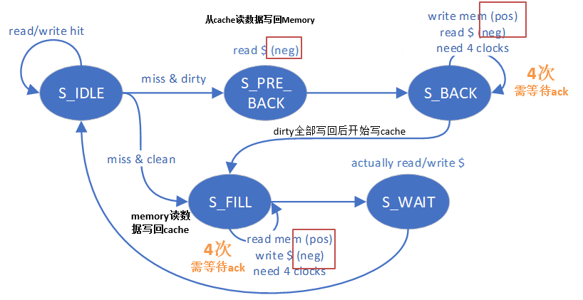

After completing the cache controller, the next task is to integrate the cache into our CPU pipeline. Furthermore, in the event that the cache is unable to promptly return data, the pipeline must stall. Therefore, a stall detection mechanism needs to be implemented within the cache controller.

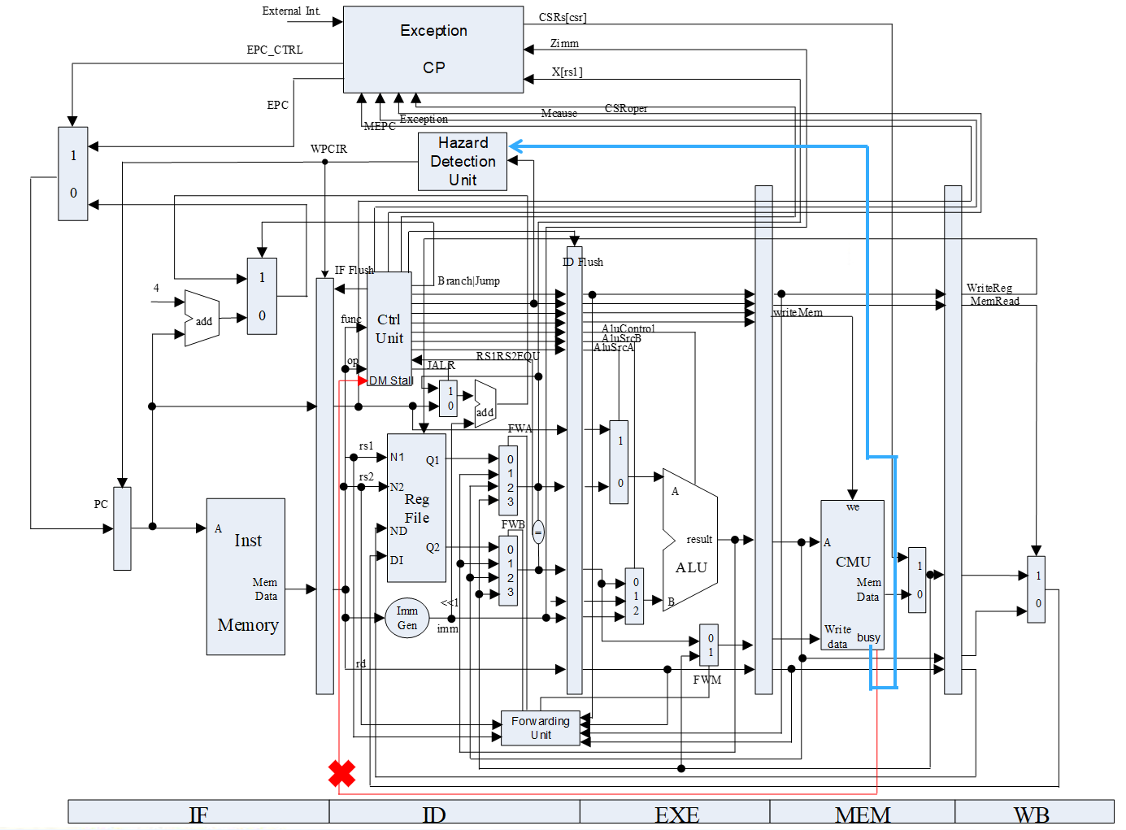

If the cache can't return data fast enough, the pipeline has to stall, so the cache controller has to make a stall judgment. The red line is wrong, the blue line is right. In the experiment, our cache stall signal will be given to the hazard detection unit, and then this unit will control the pipeline registers and the PC.

According to the above design plan, cmu.v is filled in (and the Hazard processing code is also placed in **cmu.v** in the experimental framework)

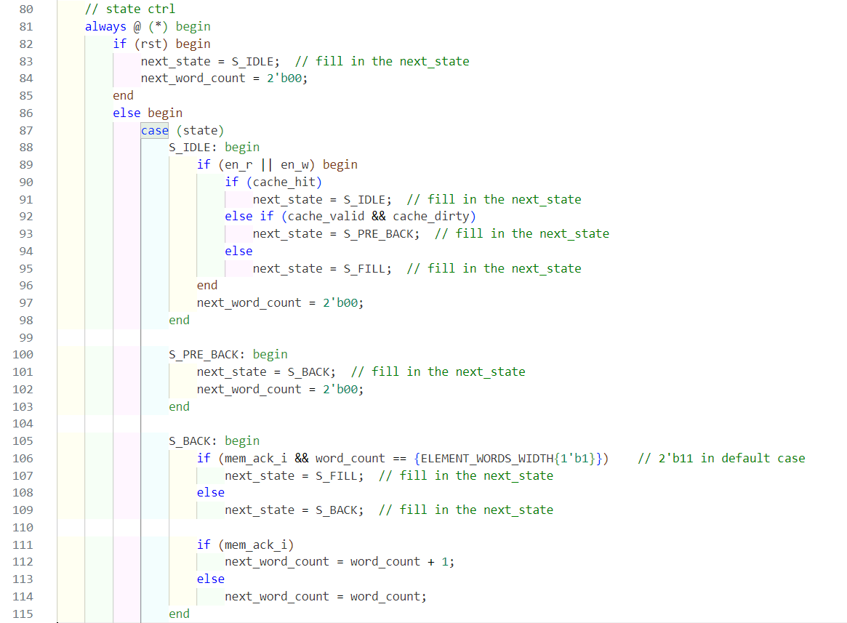

If the cache misses, according to the LRU information, select the data with the zero percent bit to replace, if the replacement is a dirty cacheline, the data should be written back to memory.

Whether to replace or write back to memory is determined by the cache controller, we only need to provide the cache line's valid information, dirty information, etc. based on the LRU information.

The process of writing back is controlled by the cache controller, when writing back, the cache controller will read the data out information and write back.

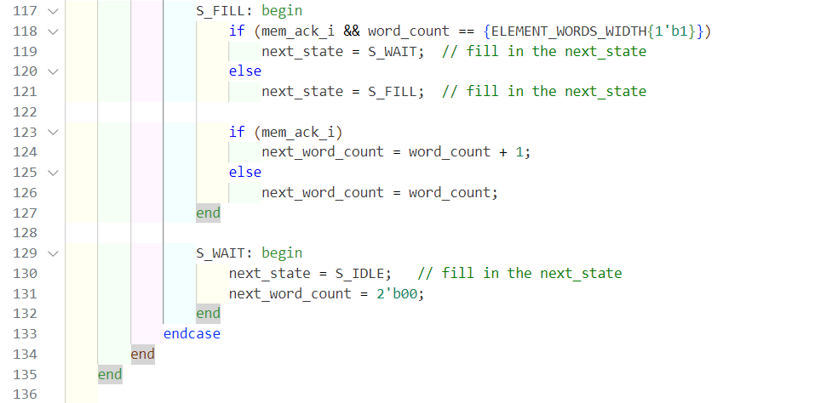

**For hazard:** In this experiment, the Hazard Detection Unit has a new input signal compared to experiment 1, and the signal of the cache controller is input from here.

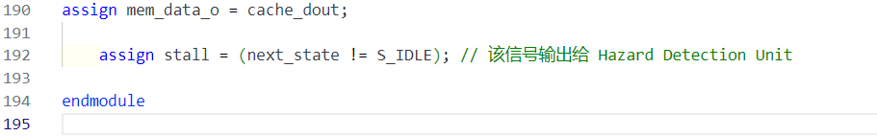

1. **Result and Analysis**

**4.1 Cache Simulation results**

The Simulation code used is as follow referring to TA’s example

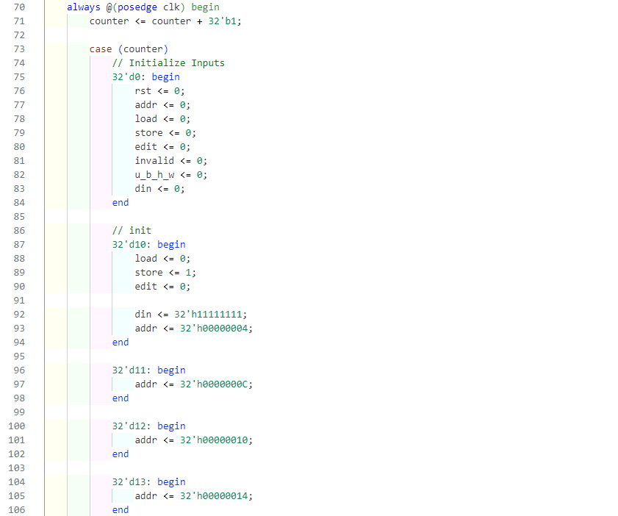

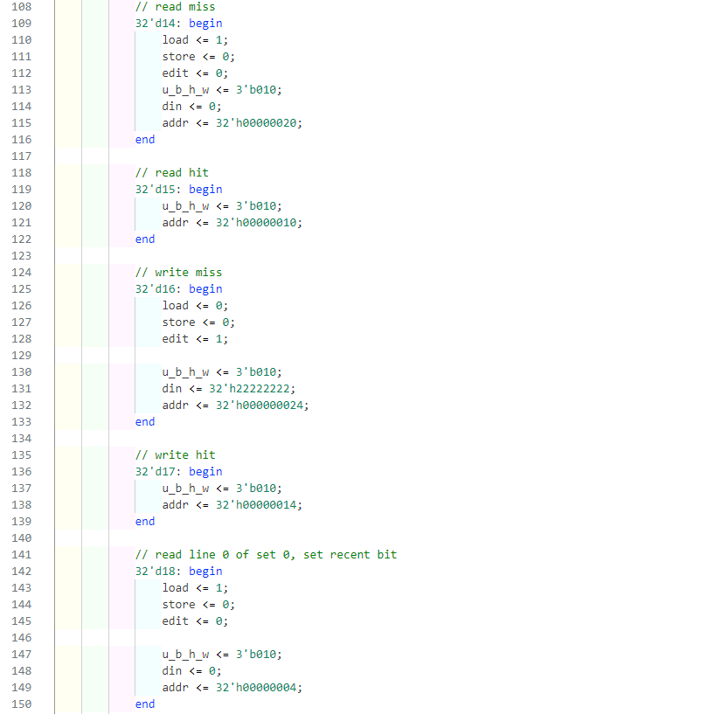

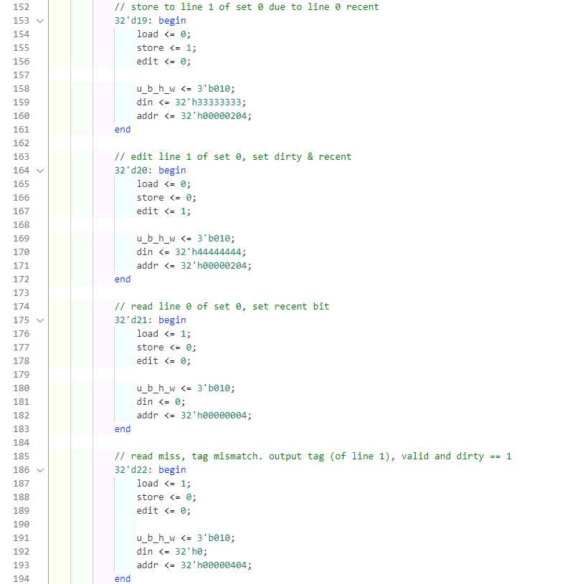

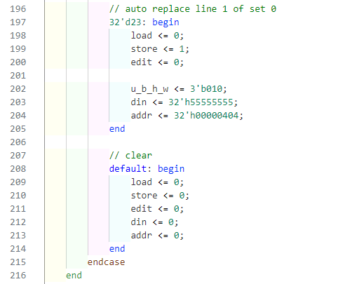

Result is:

The results of the simulation can be found to be consistent with the results in the PowerPoint given by the TA, correctly implementing cache hit and miss, and dirty replacement write back (you can see that the block with the value of 11111111 was replaced and written back to memory, and when read again 11111111 was read correctly)

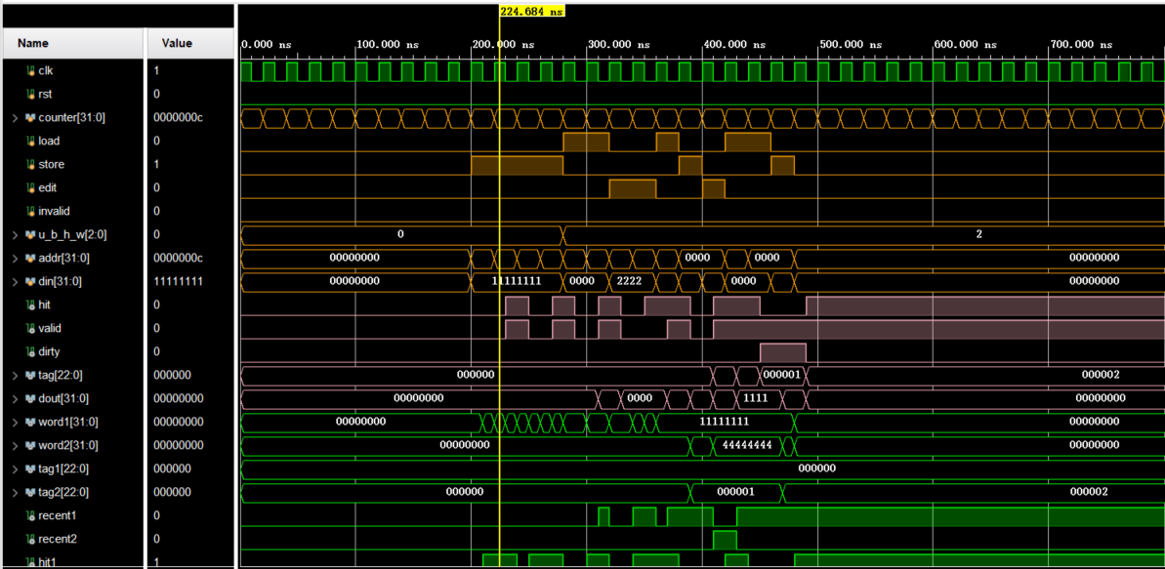

**4.2 Cache Controller Simulation results**

The Simulation Code used is as follow

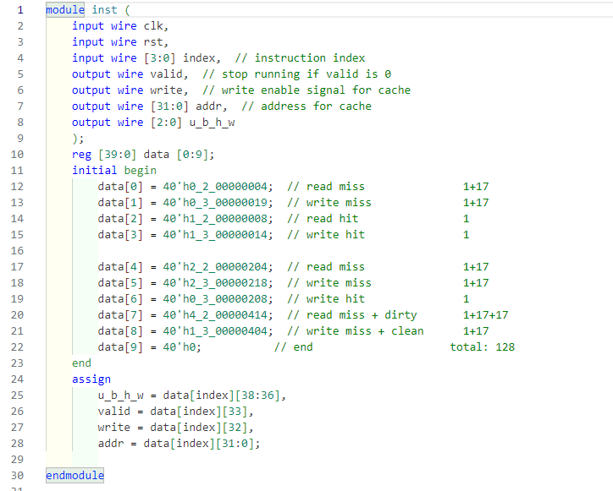

Overall as follow:

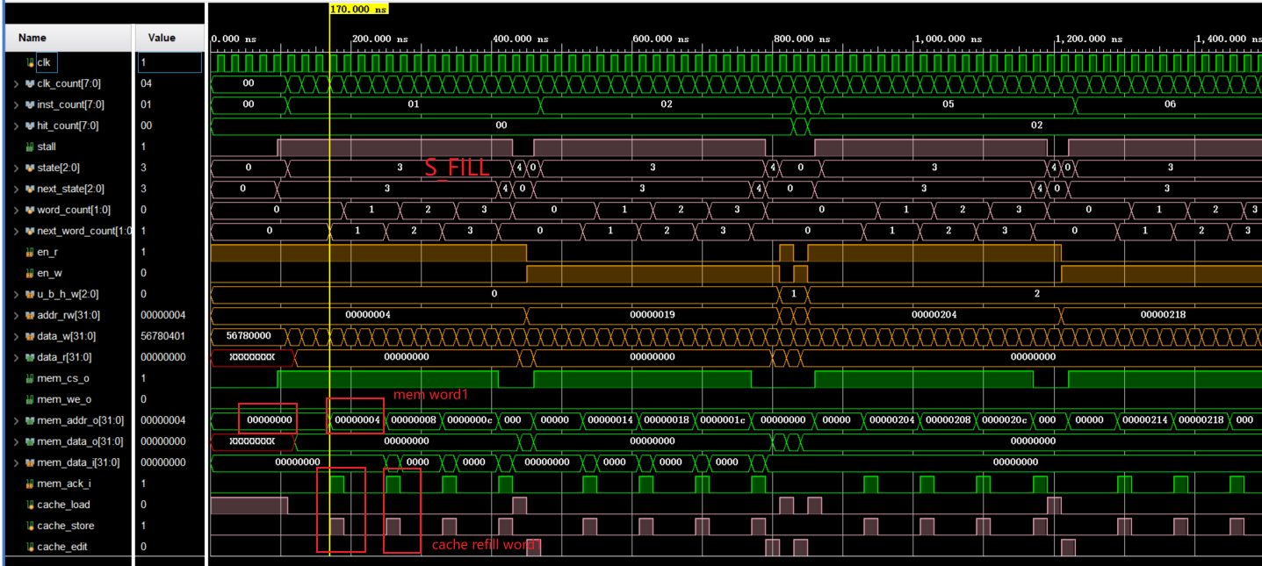

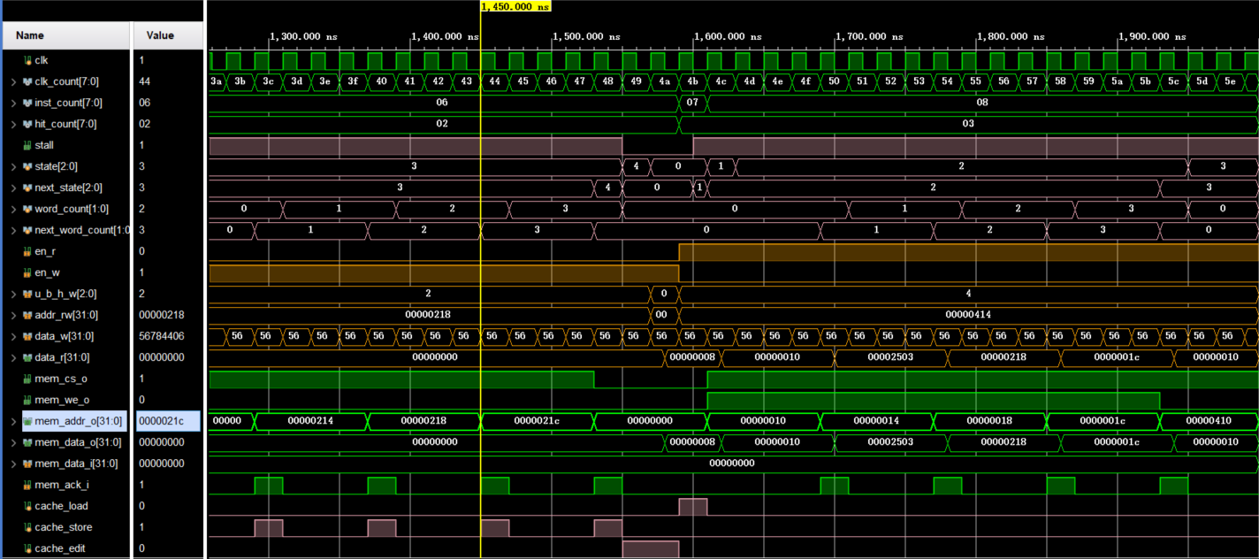

**miss & clean**

Let us analyze the simulation at initialization: The first few simulation instructions are as follows, and you can see that the cache should not be dirty at the first miss

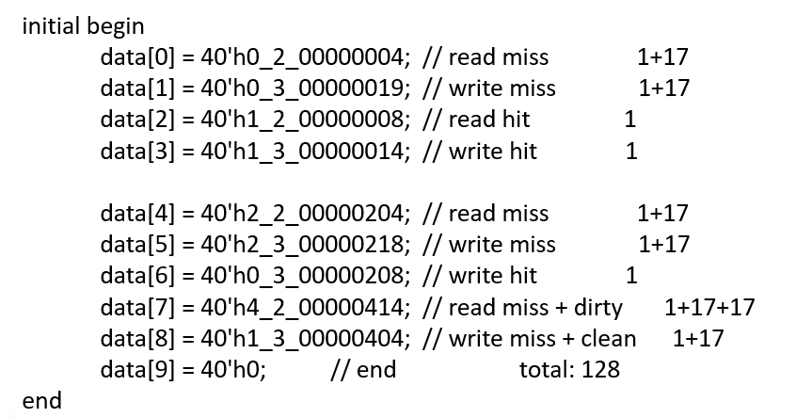

When the first lb instruction runs into the MEM phase after the miss will occur, after the miss occurs, the state value is 3, indicating that the state of S_FILL, and then began to read data from memory, we can see that it takes four cycles to read a word, and then after the end of the read is written into the cache

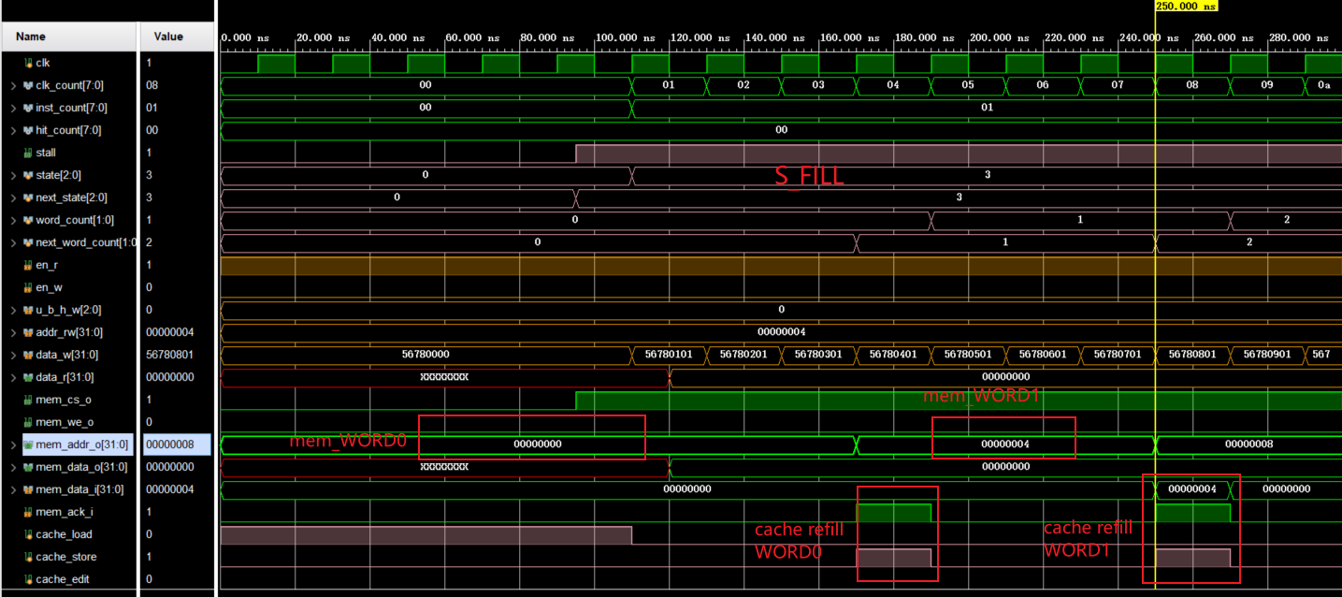

After that you can see that when the 4 values are written, you can see that it also enters an S_WAIT state and waits until the operation that was not done before is completed. After that, it enters the S_IDLE state and returns to normal. [1]

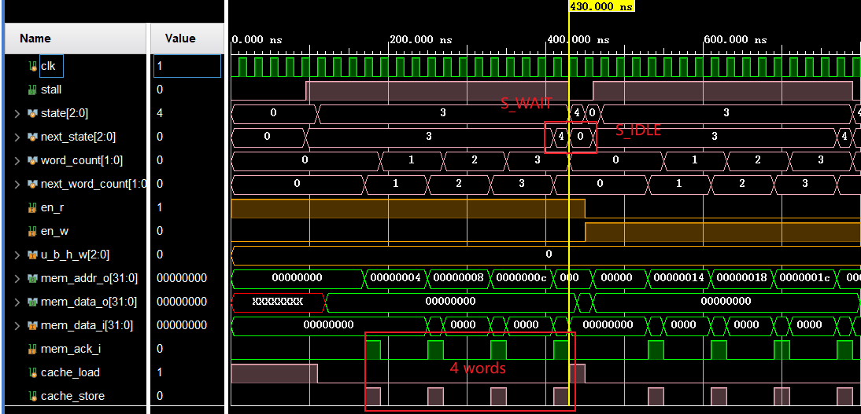

Let us analyze the simulation occurring between the time intervals of 450ns and 810ns. At the onset of 450ns, a clean cache miss event occurred. This event led to a state transition to 'S_FILL,' during which the cache was incrementally populated in accordance with the cache_din signal. Upon completion of the 'S_FILL' phase, a transition to 'S_WAIT' took place, and the cache output was made available. Concurrently, the entire pipeline operation experienced a stall.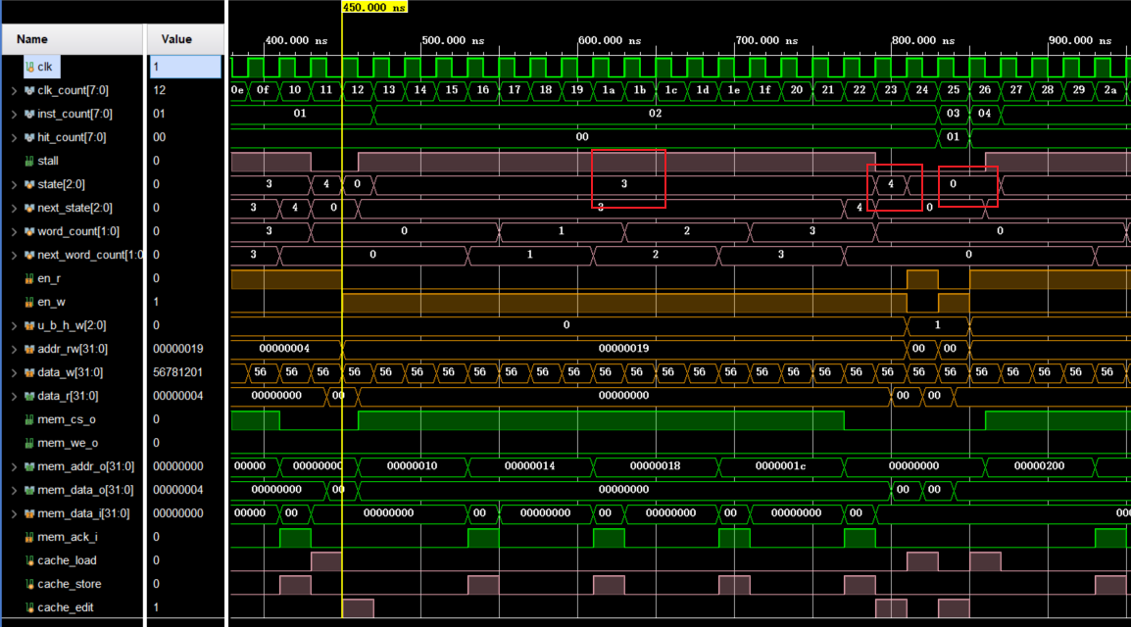

**miss & dirty**

Let's analyze another miss & dirty case

Consider the result in 1590ns-2000ns. Since our cache strategy is that in the case of miss & dirty, we need to read data from cache and write it back to memory (i.e., S_PRE_BACK state and then to S_BACK), then write data read from memory back to cache (S_FILL), then to S_WAIT and finally to S_IDLE. S_FILL), then into S_WAIT and finally back to S_IDLE, and we can see that state 2 and 3 are read and written four times in word.

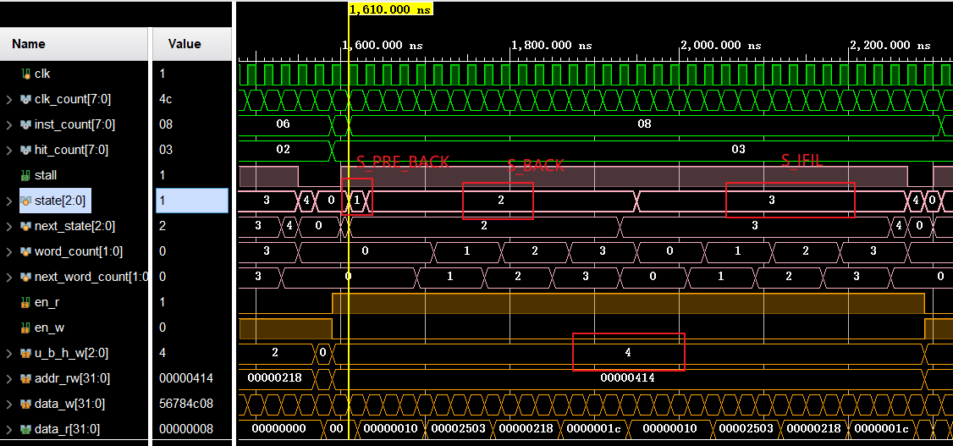

**4.3 Physical verification[2]**

**miss & clean**

I still analyze the previous instructions as an example

When running to the instruction lb x1, 0x01C(x0), the state value is 3, which means it enters the S_FILL state (the 6th position of CMU_RAM is 3), and then it starts to read the data from memory, we can see that it takes four cycles to read a word (the end of CMU_RAM varies from 1 to 4), and then it writes it into the Cache

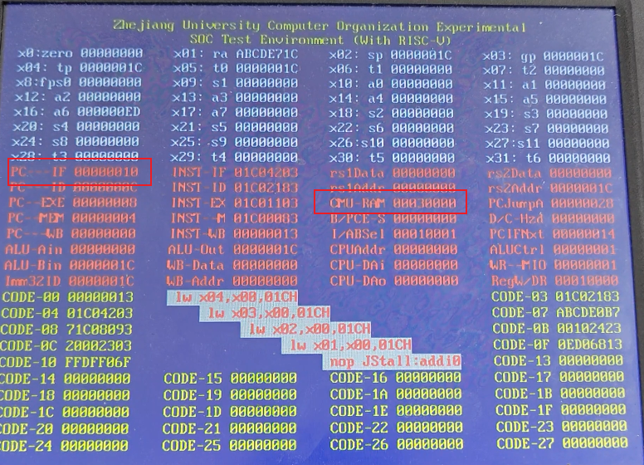

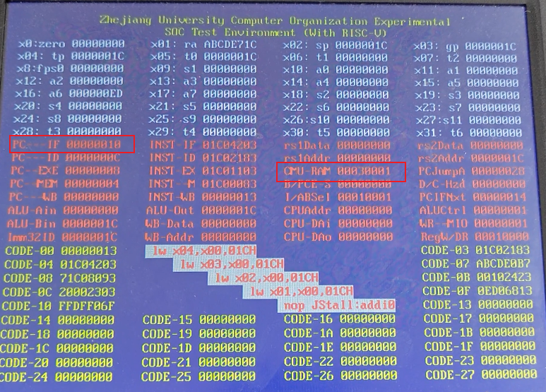

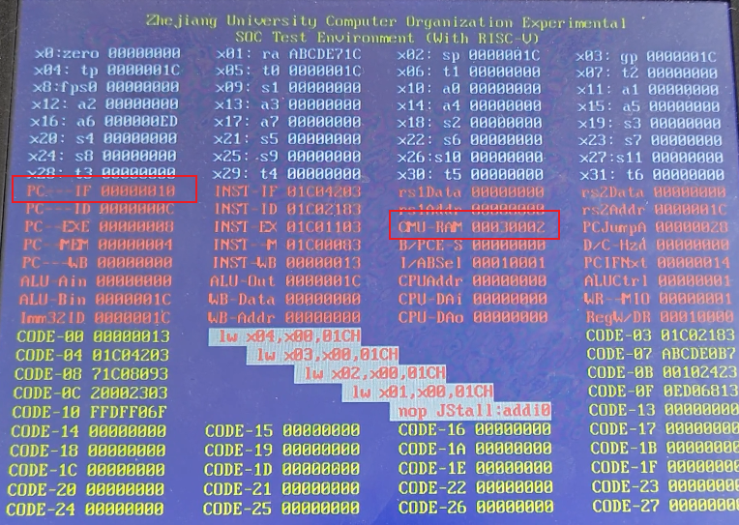

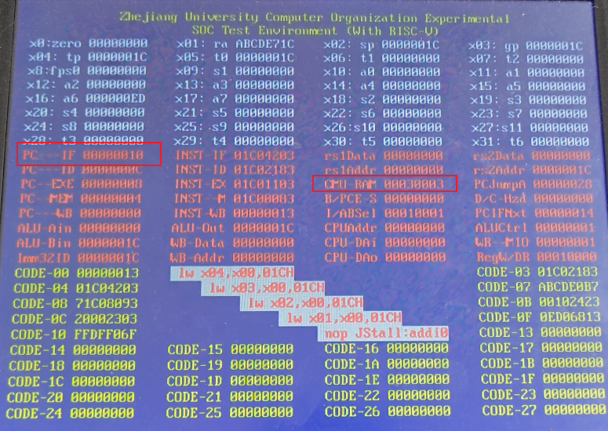

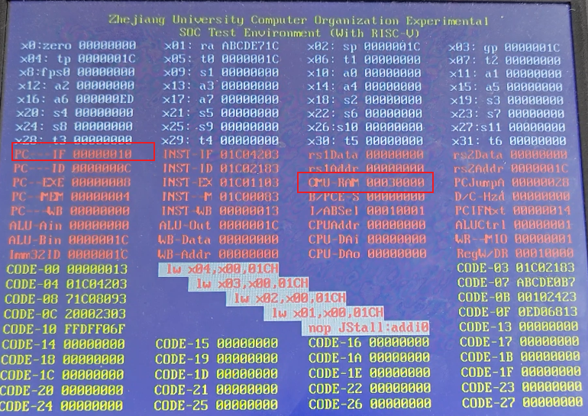

After that, we can see that when the 4 values are written, since the miss instruction is lw x0, 0x210(x0), we can see that it enters the S_WAIT state and waits until the operation that was not done before is finished. After that, it enters the S_IDLE state (bit 6 of CMU_RAM is reset to 0) and returns to normal.

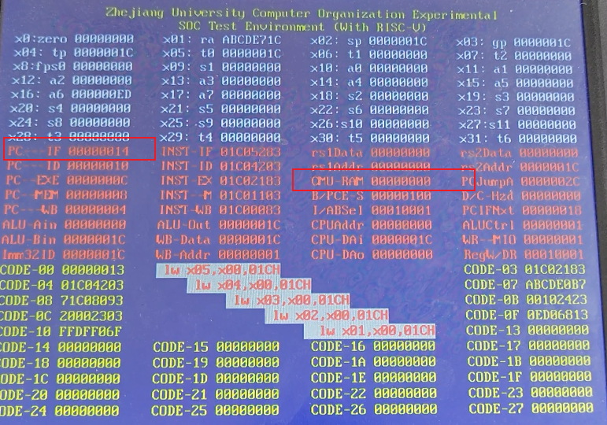

**miss & dirty**

Take 1590ns-2000ns. in the simulation code as an example, it is the same as the analyzed one

Consider the result in 1590ns-2000ns. Since the strategy of our cache is that in the case of miss&dirty, we need to read data from the cache and write it back to memory first (i.e., the state of S_PRE_BACK(bit 6 of CMU_RAM is reset to 1) and then to the state of S_BACK(bit 6 of CMU_RAM is reset to 2)), and then to the state of S_BACK(bit 6 of CMU_RAM is reset to 2). BACK(bit 6 of CMU_RAM is reset to 2))

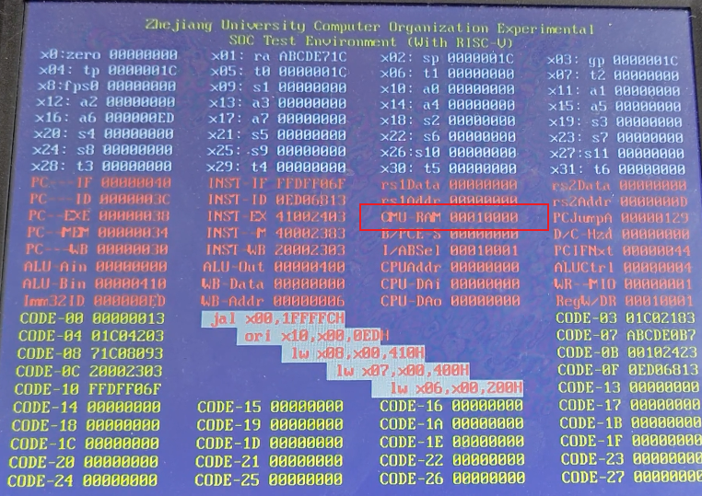

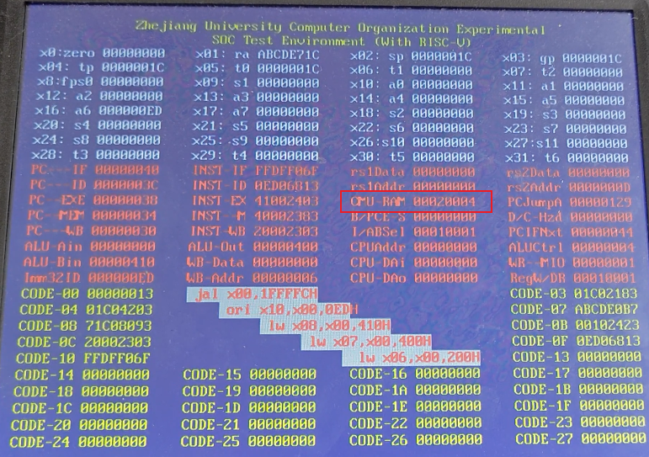

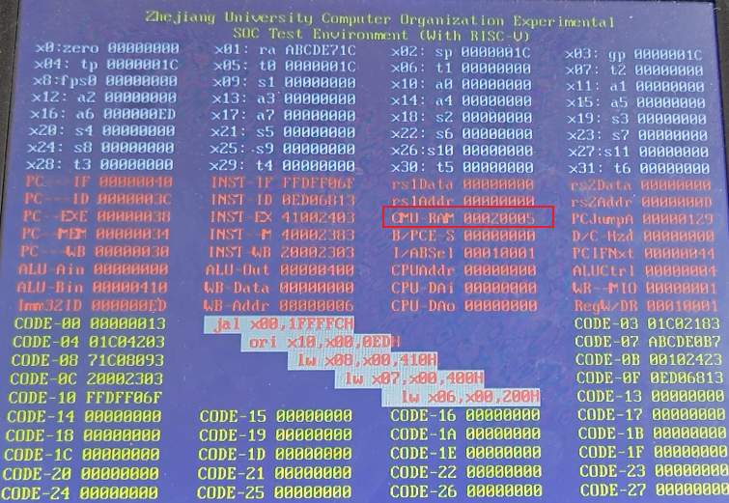

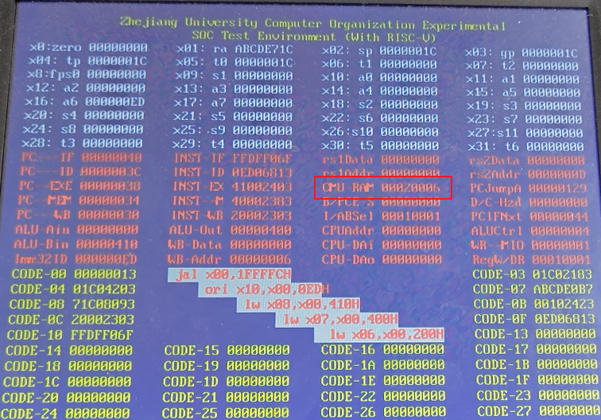

Then it enters state 3

Then it writes the data read from memory back to cache(S_FILL), then enters S_WAIT and finally returns to S_IDLE, and it can be found that the state reads and writes four times in word while staying in 2 and 3 (the lowest bit of the CMU_RAM varies from 4-6, 0-3).

After that, the situation is similar to the previous result, so I won't give the picture again.

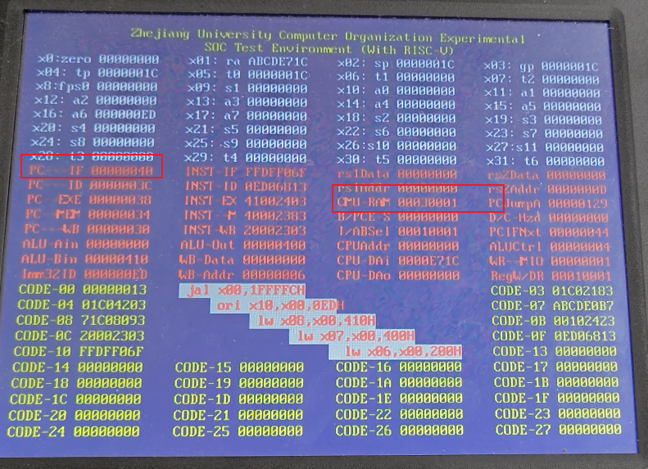

1. **Discussion and thoughts**

Through experiments 3 and 4, I gained a deeper understanding of cache design, CPU pipelines with caches, cache management units (CMUs), and the implementation of a two-way set-associative cache. Since we had previously implemented cache-related components in lab 2, this experiment presented no significant challenges during the process. Nevertheless, it further enhanced my comprehension of pipeline architecture and operations.

1. The picture after this line was added. Due to the limitation of the device screen width, the middle lines in the simulation were deleted. The remaining pictures were captured in the same simulation.
2. Updates to RAM are not shown because acceptance and reporting were completed before the new requirements were assigned (already demonstrated with the instructor during the repeat acceptance process and the relevant requirements have been met)